RETAINING BRACES
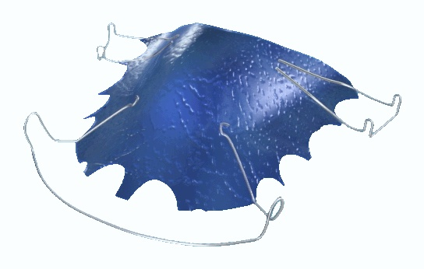

Q What are retaining braces?

A Retaining braces (retainers) are needed to keep your teeth in line once your orthodontic treatment has been completed.

Q Why do I need retaining braces?

A Your teeth will try to drift back and go crooked again even after treatment has finished. If you wear the retainers for the specified period then eventually your teeth should settle into their new positions and be less likely to move back. However everyone’s teeth do change throughout life as well so the only way to ensure your teeth remain straight is to wear your retainer indefinitely.

Q When do I wear my retainer?

A There are two types of retainer the plastic gum shield type and the plate type.

The plastic gum shield type of retainer should be worn every night for at least a year.

The plate type should be worn full time for twelve weeks then at night for at least 9 months.

Q How do I care for my retainer?

A There are a few points to consider when using your retainer, which will ensure its long and useful life.

- Use both hands to insert and remove your retainer.
- Clean your retainer carefully
- Keep your retainer in its box when you are not using it.

Q How do I clean my retainer?

A First rinse the retainer under the tap. Then gently use your toothbrush. You can use a specialist cleaner which can be purchased from your dental receptionist.

Q What happens if I break my retainer?

A If you break your retainer you should make an urgent appointment to see your dentist who will take an impression for a new one.

